**Lab Practical #05:**

Study the concept of VLAN using packet tracer.

**Practical Assignment #05:**

1. **Implement the different network structures in VLAN and VLAN trunking. Also check connectivity between them using ping command or PDU utility.**
2. **VLAN - 1 :**

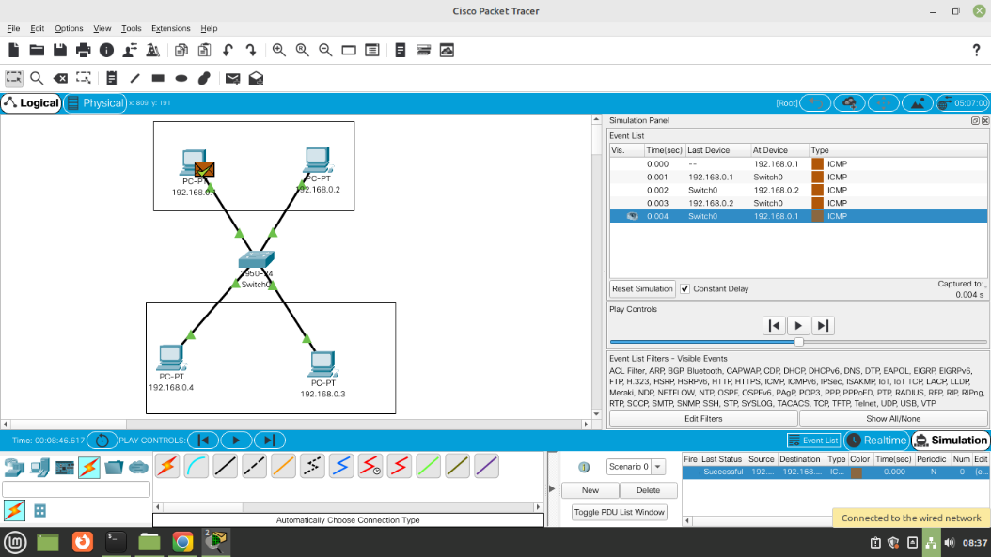

1. **VLAN – 1 (Database) :**

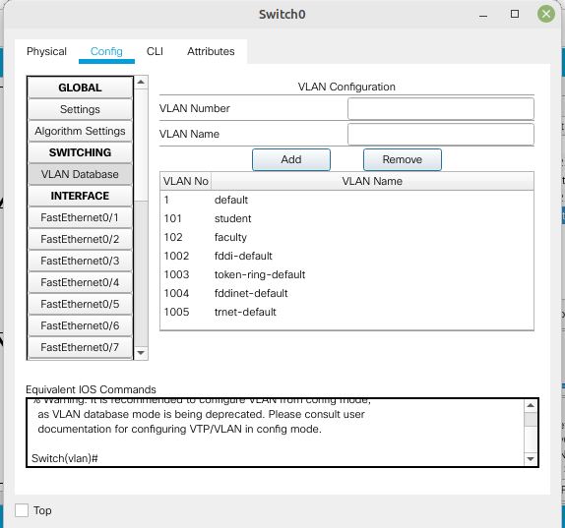

1. **VLAN – 1 (PDU Information) :**

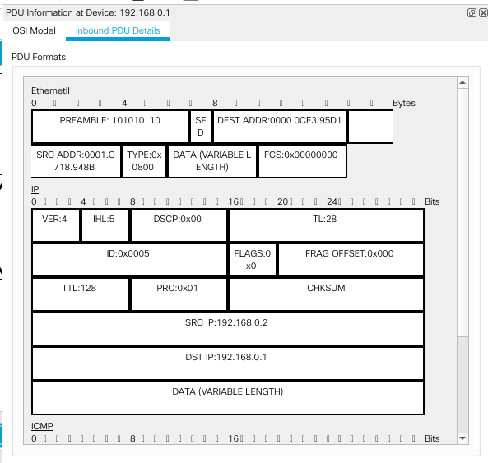

1. **VLAN - 2 :**

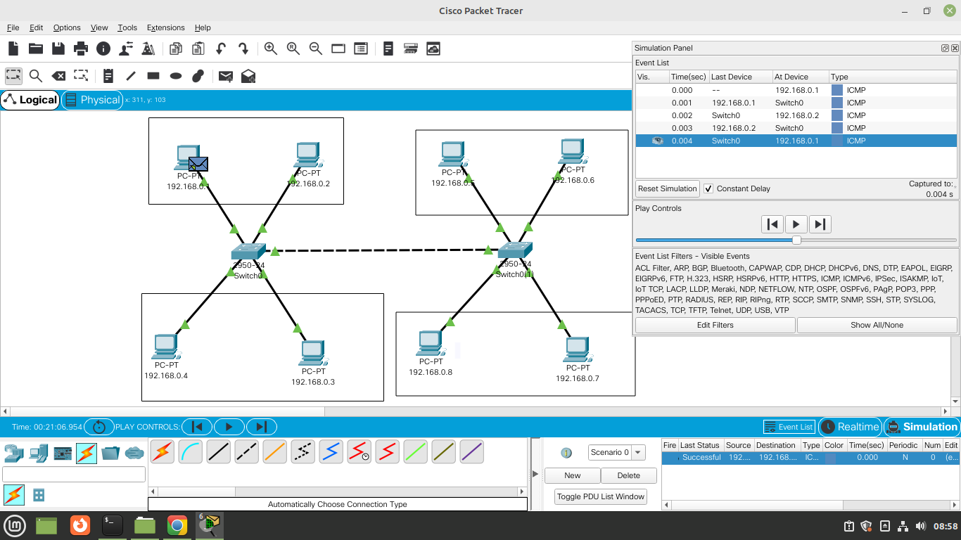

1. **VLAN - 2 (Database) :**

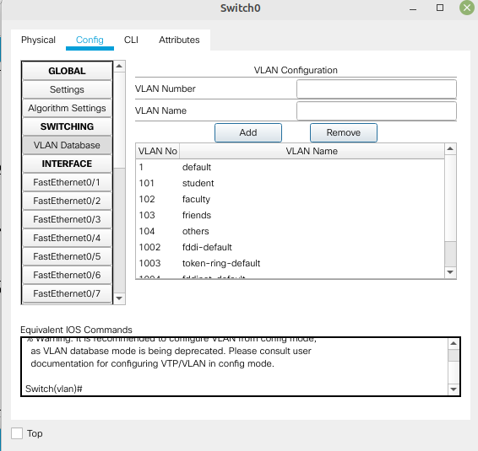

1. **VLAN – 2 (PDU Information) :**

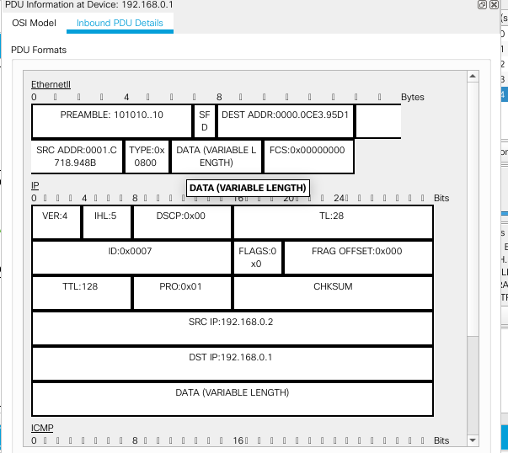

1. **VLAN - 3 :**

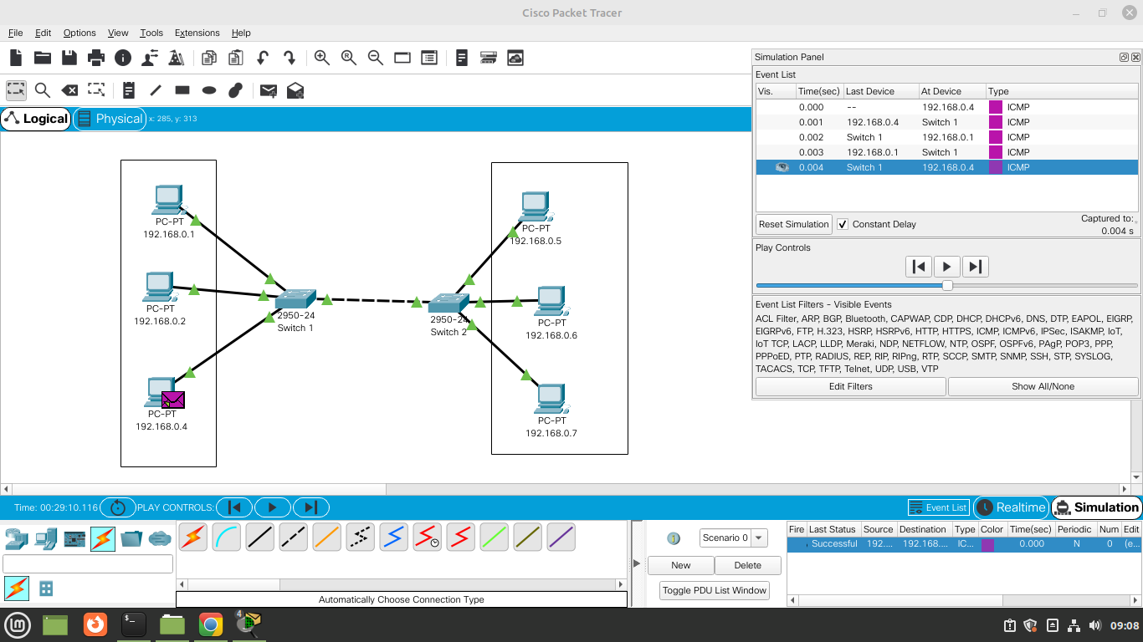

1. **VLAN – 3 (Database) :**

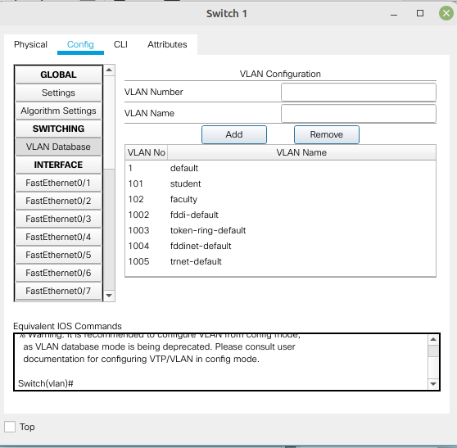

1. **VLAN – 3 (PDU Information) :**

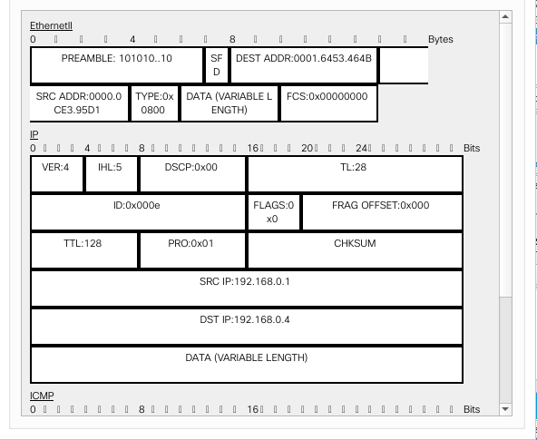

1. **VLAN - 4 :**

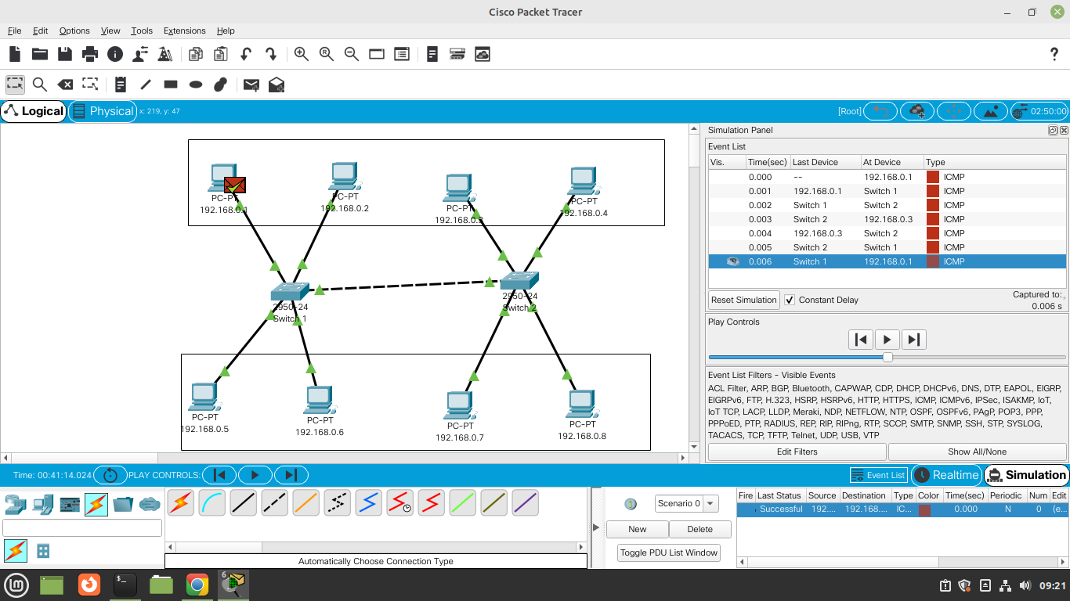

1. **VLAN – 4 (Database) :**

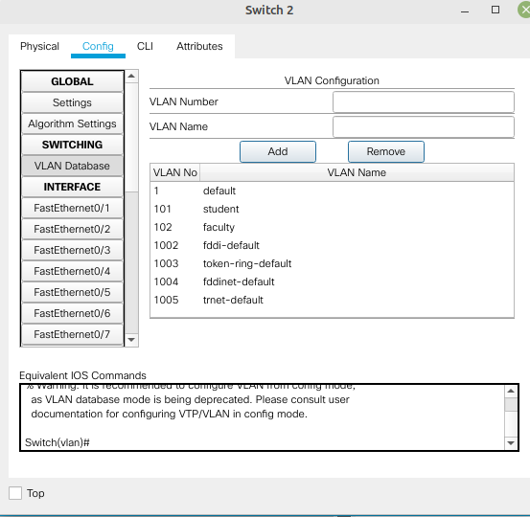

1. **VLAN – 4(PDU Information) :**

